In interior design, creating a space that balances functionality with aesthetic appeal relies on effective spatial planning and flow management. This ensures that each area is designed for optimal use, comfort, and accessibility, enhancing the experience of those who inhabit it. We are going to explore three foundational techniques for spatial planning and flow:

* Functional Zoning,
* Traffic Flow Schemes - Developing Bubble Diagrams, Layout Experimentation,
* Traffic Flow Analysis

By mastering these techniques, interior designers can craft interiors that support both movement and purpose harmoniously.

# Functional Zoning: The Foundation of Purposeful Spaces

Fig. 1. Agua Nico, Pinterest (2024), Circulation Zones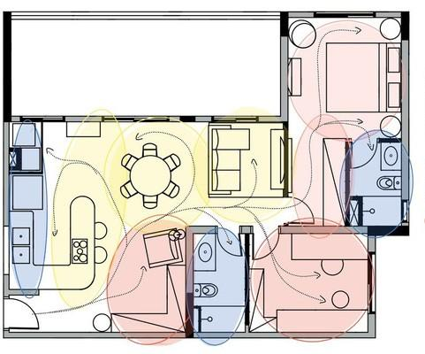

Functional zoning is the practice of dividing a space into distinct areas, each dedicated to specific activities. This technique is used in both residential and commercial spaces, where clear zoning can enhance usability, minimise clutter, and improve overall flow. Here's how functional zoning contributes to spatial planning.

### Purpose-Driven Design

Zoning begins with understanding the function of each area within a space. In a home, for example, common zones may include cooking, dining, working, relaxing, and sleeping. In an office, zoning may separate workstations, meeting areas, lounges, and communal spaces. By identifying these zones, a designer creates a purposeful foundation for the space that supports the desired activities.

### Defining Boundaries and Transitions:

Once zones are identified, boundaries between them can be defined with partitions, furniture arrangements, or even lighting variations. Designers can create transitions between zones through flooring changes, colour schemes, or different wall finishes, subtly guiding occupants from one area to another. A kitchen zone, for instance, might be marked by tile flooring, while a dining zone might feature wood, offering a visual cue for the shift in activity.

### Maximising Usability and Accessibility:

Effective zoning maximises usability by positioning functional areas where they are most accessible and intuitive. For instance, a dining area would ideally be adjacent to the kitchen, and a workspace might benefit from proximity to natural light. This not only streamlines daily activities but also makes the space more enjoyable and efficient.

# **Developing Bubble Diagrams, Layout Experimentation, and Traffic Flow Schemes**

Once functional zones and traffic flow paths have been outlined, designers can start translating these ideas into practical layouts using visual tools like bubble diagrams, layout experimentation, and traffic flow schemes.

### Bubble Diagrams

Bubble diagrams are a preliminary visual tool that helps designers map out spatial relationships and transitions. Each zone is represented as a “bubble” on a sketch, with the size and position indicating its importance and relationship to other areas. Here’s how bubble diagrams help:

Visualising Zone Relationships:Designers can quickly experiment with the proximity of zones, such as placing dining areas next to kitchens or meeting rooms near open workspaces.

Adjusting Flow and Adjacency: Bubble diagrams make it easy to identify areas where flow could be interrupted, such as placing storage in an area that disrupts a main pathway.

Experimenting with Scale and Position: The size of bubbles can represent the relative space needed for each zone, providing a useful first step in determining room proportions.

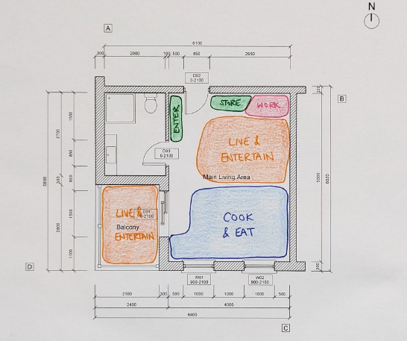

Fig. 2. Student example (2024), Bubble diagram

### Layout Experimentation

After creating bubble diagrams, designers move to a more detailed layout experimentation phase. This step involves:

**Testing Various Layout Options:** By sketching or using design software, designers can test different configurations to find the most functional and aesthetically pleasing setup.

**Adjusting Furniture and Flow:** This stage also allows for experimentation with furniture placement and traffic flow adjustments, ensuring the space will be navigable and inviting.

### Traffic Flow Schemes

Traffic flow schemes are a detailed analysis of movement within the finalised layout. These schemes go beyond general flow to assess specific routes and usage patterns.

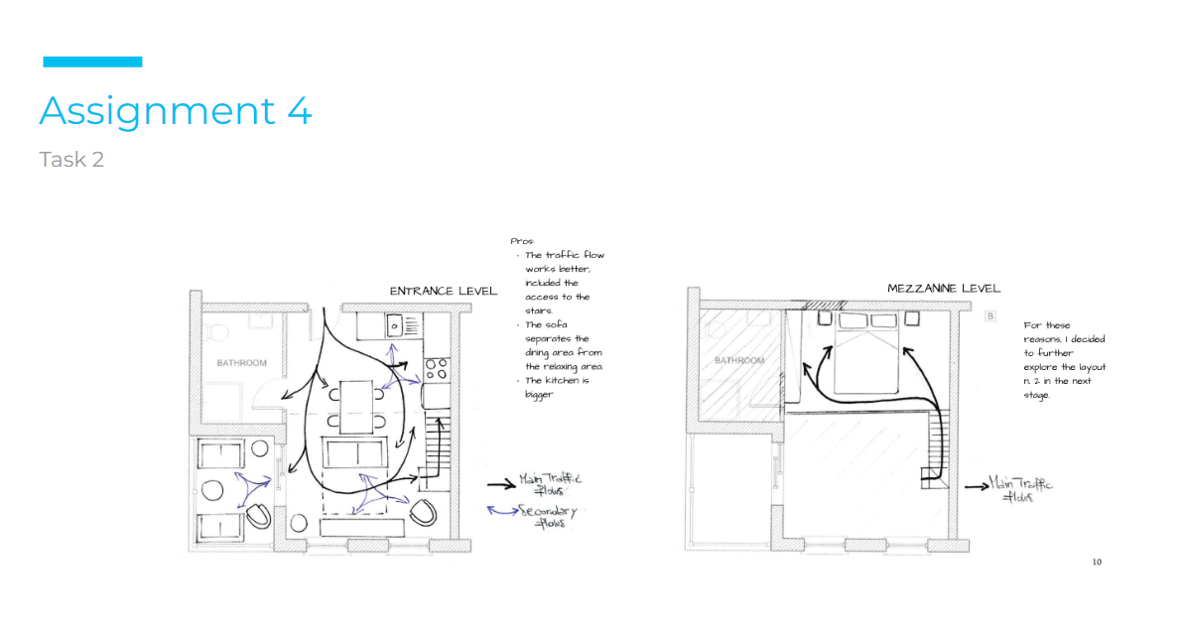

Fig. 3. Student example (2024), Traffic Flow Scheme

**Mapping Out Circulation Paths:** This involves drawing pathways on the layout, indicating primary and secondary paths. It provides a clear visual of how people will move through the space.

**Avoiding Congestion Zones:** By identifying areas that may become crowded or obstructed, designers can refine the layout to prevent potential issues.

**Incorporating Flexibility:** Traffic flow schemes should account for potential changes in the space’s use. For example, if more desks or collaborative spaces are needed in an office, a flexible seating area can allow for reconfiguring pathways.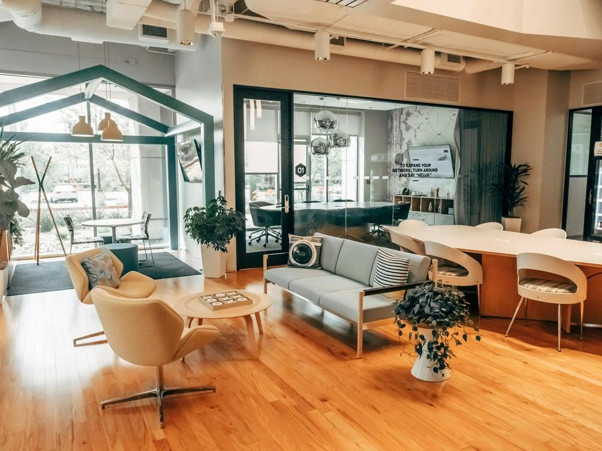

Fig. 3. Pexels (2024), Open Plan Office Space with Seating

**Traffic Flow Analysis: Designing for Seamless Movement**

Traffic flow analysis is the examination of movement within a space to ensure it accommodates users without causing congestion or discomfort. For designers, analysing traffic flow is vital to creating a natural, unimpeded path that promotes comfort and efficiency.

* + 1. **Identifying Primary Pathways**

Primary pathways are the main routes people take to navigate the space. These should be kept clear and unobstructed, with enough width to comfortably accommodate movement. In residential spaces, primary pathways might include the path from the front door to the living room, while in a commercial setting, it could be the route from the reception to workstations.

## Determining Secondary Pathways

Secondary pathways are less frequently used routes that connect secondary spaces, such as storage rooms or secondary exits. While these pathways don’t require as much space, they still need to be accessible and functional

## Ensuring Accessibility and Safety

Traffic flow analysis also considers accessibility for all individuals, including those with mobility issues. Door widths, floor levels, and furniture placement should accommodate wheelchairs or mobility aids where necessary. Ensuring smooth, logical pathways contributes to both safety and ease of use.

## Balancing Flow and Interaction

In social spaces, designers will also need to consider traffic flow as a means to encourage interaction. In an open-plan office, for instance, placing informal seating along primary pathways (Fig 3) can encourage spontaneous casual conversation among colleagues. Alternatively, in a home, an open kitchen adjacent to a seating area allows the cook to engage with guests while preparing meals

In interior design, creating functional, comfortable, and beautiful spaces depends on thoughtful spatial planning and flow techniques. By strategically zoning areas, analysing traffic flow, and utilising tools like bubble diagrams, designers can approach each project with a strong foundation and clear vision. With practice and creativity, these foundational skills empower designers to enhance the usability, safety, and appeal of every space they create.